Case Study 1: Personal Portfolio
1. Problem Statement
To develop a personal portfolio program that displays a student's name, age, skills, and hobbies.
2. Objectives
- To display personal details.
- To show skills and hobbies.
- To learn basic Python programming.
3. Assumptions
- The user enters valid details.
- The student has at least one skill and hobby.
4. Algorithm
- Start.
- Enter the student's name and age.
- Enter skills and hobbies.
- Display all details.
- Stop.
5. Flowchart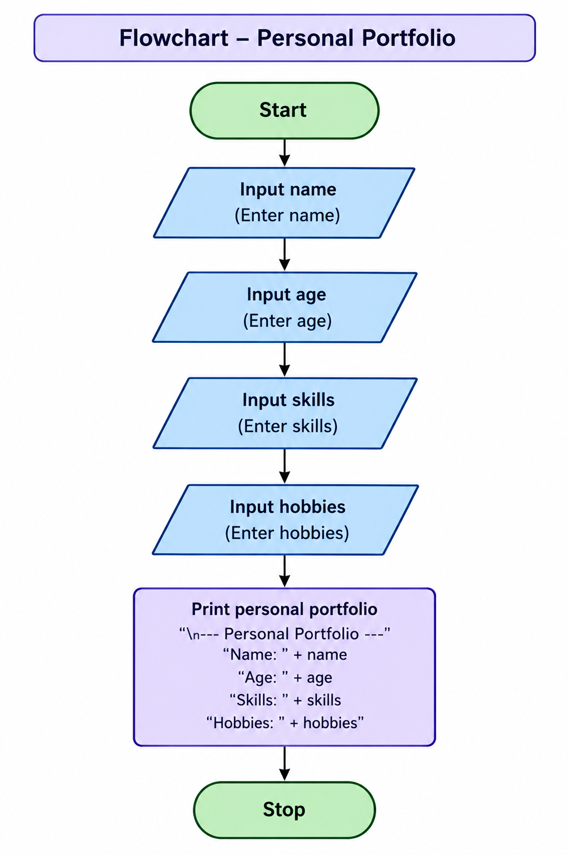
6. Pseudocode
START
INPUT name
INPUT age
INPUT skills
INPUT hobbies
PRINT name, age, skills, hobbies
STOP

7. Python Source Code
name = input("Enter name: ")
age = input("Enter age: ")
skills = input("Enter skills: ")
hobbies = input("Enter hobbies: ")

print("\n--- Personal Portfolio ---")
print("Name:", name)
print("Age:", age)
print("Skills:", skills)
print("Hobbies:", hobbies)

8. Test Cases (Any 3)
Test | Name | Age | Expected result
1 | Ravi | 18 | Details displayed
2 | Sita | 19 | Details displayed
3 | Arun | 20 | Details displayed
9. Screenshots
10. Conclusion
Thus, the Personal Portfolio program was developed successfully using Python to display personal details.
Case Study 2: College Information System
1. Problem Statement
To develop a Python program to display college details such as college name, course, department, and location.
2. Objectives
- To display college information.
- To understand variables and input statements.
- To print information clearly.
3. Assumptions
- The user enters valid college details.
- All details are available.
4. Algorithm
- Start.
- Enter college name.
- Enter course, department, and location.
- Display all details.
- Stop.
5. Flowchart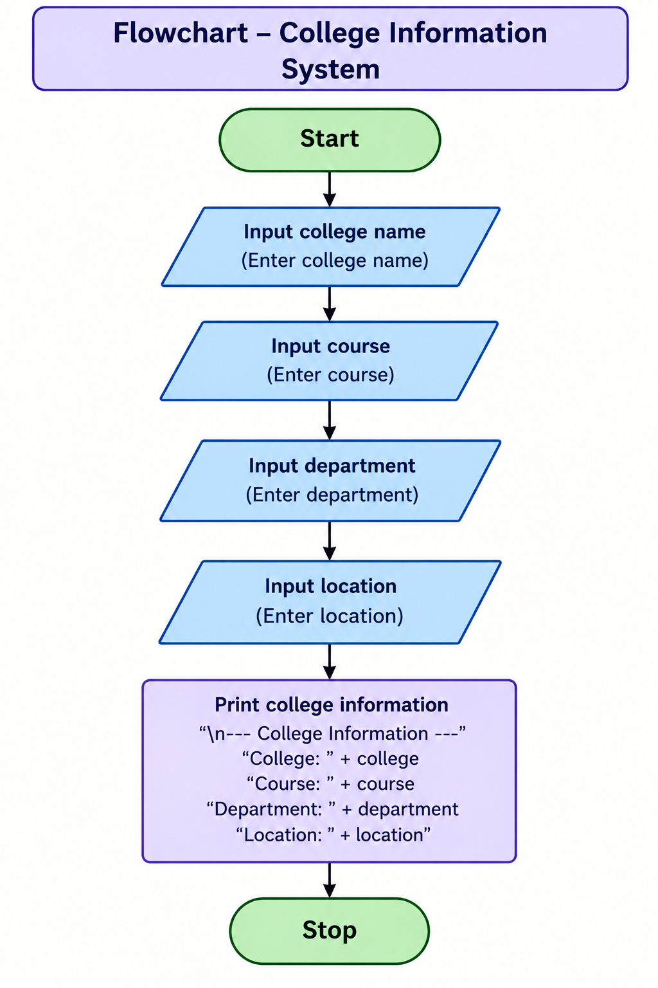
6. Pseudocode
START
INPUT college_name
INPUT course
INPUT department
INPUT location
PRINT all college details
STOP
7. Python Source Code
college = input("Enter college name: ")
course = input("Enter course: ")
department = input("Enter department: ")
location = input("Enter location: ")

print("\n--- College Information ---")
print("College:", college)
print("Course:", course)
print("Department:", department)
print("Location:", location)

8. Test Cases (Any 3)
Test | College | Course | Expected result
1 | ABC College | B.Tech | Details displayed
2 | XYZ College | B.Sc | Details displayed
3 | PQR College | B.Com | Details displayed
9. Screenshot

10. Conclusion
Thus, the College Information System was developed successfully using Python to display college details.
Case Study 3: Online Food Ordering System
1. Problem Statement
To develop a simple Python program that allows users to select a food item and calculate the total bill.
2. Objectives
- To display a food menu.
- To accept the user's choice and quantity.
- To calculate the total price.
3. Assumptions
- Pizza costs ₹150.
- Burger costs ₹100.
- Sandwich costs ₹80.
- The user enters a valid menu choice and positive quantity.
4. Algorithm
- Start.
- Display the food menu.
- Enter the food choice.
- Enter the quantity.
- Calculate the total bill.
- Display the bill.
- Stop.
5. Flowchart
Start
Display food menu
Enter choice and quantity
Calculate total bill
Display total bill
Stop
6. Pseudocode
START
DISPLAY food menu
INPUT choice
INPUT quantity

IF choice = 1
price = 150
ELSE IF choice = 2
price = 100
ELSE IF choice = 3
price = 80
ELSE
PRINT "Invalid choice"
STOP
END IF

total = price * quantity
PRINT total
STOP
7. Python Source Code
print("Food Menu")print("1. Pizza - Rs.150")print("2. Burger - Rs.100")print("3. Sandwich - Rs.80")choice = int(input("Enter your choice: "))quantity = int(input("Enter quantity: "))if choice == 1: price = 150elif choice == 2: price = 100elif choice == 3: price = 80else: price = 0 print("Invalid choice")if choice in [1, 2, 3]: total = price * quantity print("Total Bill: Rs.", total)
8. Test Cases (Any 3)
Test | Choice | Quantity | Expected output
1 | 1 (Pizza) | 2 | ₹300
2 | 2 (Burger) | 3 | ₹300
3 | 3 (Sandwich) | 2 | ₹160
9. Sample Output
Food Menu
1. Pizza - Rs.150
2. Burger - Rs.100
3. Sandwich - Rs.80
Enter your choice: 1
Enter quantity: 2
Total Bill: Rs. 300
10. Conclusion
Thus, the Online Food Ordering System was developed successfully using Python to select food items and calculate the total bill.

Case 4: Employee Payroll and Deduction Analysis

1.PROBLRM STATEMENT:
Calculate gross salary from basic pay, allowances, overtime, and incentives; apply progressive deductions and generate a formatted salary statement.

2.OBJECTIVES:
- To calculate the gross salary of an employee.
- To calculate progressive deductions based on salary.
- To determine the net salary after deductions.
- To display a formatted salary statement.
3. Assumptions
- Basic pay, allowances, overtime pay, and incentives are entered by the user.
- Gross salary is the sum of basic pay, allowances, overtime pay, and incentives.
- Deductions are calculated using the following example rates:
  - Gross salary up to ₹20,000: 5%
  - Next ₹20,000: 10%
  - Remaining salary above ₹40,000: 15%
- Net salary is calculated by subtracting total deductions from gross salary.
- All amounts are entered in Indian rupees.
Note: These deduction rates are assumed for this case study and do not represent actual statutory payroll tax rates.
4. Algorithm
- Start.
- Read the employee's name.
- Input basic pay, allowances, overtime pay, and incentives.
- Calculate gross salary.
- Calculate deductions using progressive rates.
- Calculate net salary.
- Display the formatted salary statement.
- Stop.

5.FLOW CHART:
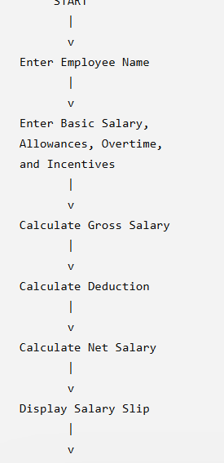

6.PSEUDO CODE:
START

INPUT employee_name
INPUT basic_pay
INPUT allowances
INPUT overtime_pay
INPUT incentives

gross_salary = basic_pay + allowances
+ overtime_pay + incentives

IF gross_salary <= 20000
deduction = gross_salary * 0.05

ELSE IF gross_salary <= 40000
deduction = 20000 * 0.05
+ (gross_salary - 20000) * 0.10

ELSE
deduction = 20000 * 0.05
+ 20000 * 0.10
+ (gross_salary - 40000) * 0.15

net_salary = gross_salary - deduction

DISPLAY salary statement

STOP

7.PYTHON SOURSE CODE:
# Employee Payroll Analysis

name = input("Enter employee name: ")

basic = float(input("Enter basic salary: "))
allowances = float(input("Enter allowances: "))
overtime = float(input("Enter overtime: "))
incentives = float(input("Enter incentives: "))

# Calculate gross salary
gross = basic + allowances + overtime + incentives

# Calculate deduction
if gross <= 20000:
deduction = gross * 0.05
elif gross <= 40000:
deduction = 1000 + (gross - 20000) * 0.10
else:
deduction = 3000 + (gross - 40000) * 0.15

# Calculate net salary
net = gross - deduction

# Display salary slip
print("\n--- SALARY SLIP ---")
print("Employee:", name)
print("Gross Salary:", gross)
print("Deduction:", deduction)
print("Net Salary:", net)

8.TESTCASES:
Test Cases
Test Case 1:
- Input: Basic Salary = ₹15,000, Allowances = ₹2,000, Overtime = ₹1,000, Incentives = ₹1,000.
- Expected Output: Gross Salary = ₹19,000, Deduction = ₹950, Net Salary = ₹18,050.
Test Case 2:
- Input: Basic Salary = ₹25,000, Allowances = ₹5,000, Overtime = ₹2,000, Incentives = ₹3,000.
- Expected Output: Gross Salary = ₹35,000, Deduction = ₹2,500, Net Salary = ₹32,500.
Test Case 3:
- Input: Basic Salary = ₹35,000, Allowances = ₹8,000, Overtime = ₹3,000, Incentives = ₹4,000.
- Expected Output: Gross Salary = ₹50,000, Deduction = ₹4,500, Net Salary = ₹45,500.

9.OUTPUT:
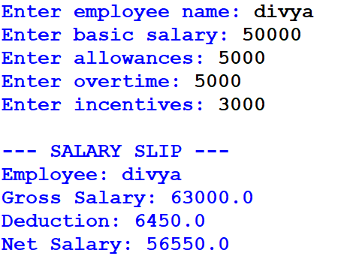

10.CONCLUSION
This case study demonstrates how Python can be used to automate employee payroll calculations. It uses variables, user input, arithmetic operations, conditional statements, and formatted output to calculate gross salary, progressive deductions, and net salary. It reduces manual calculation errors and generates a clear salary statement.

CASE 5: Multi-Plan Telecommunications Cost Optimization

1.PROBLEM STATEMENT:
Evaluate several mobile plans against usage, validity, and budget constraints; calculate excess charges and identify the most economical eligible plan.

2.OBJECTIVES:
• Compare different mobile recharge plans.
• Check data usage and validity.
• Calculate extra charges.
• Select the cheapest eligible plan.
3. Assumptions
- Three mobile plans (Plan A, Plan B, and Plan C) are available.
- Each plan has a fixed price, daily data allowance, validity, and extra data charge.
- The user enters the required data usage in GB, validity in days, and budget.
- Extra charges are calculated when data usage exceeds the plan's total data allowance.
- Only plans that satisfy the required validity and budget are considered eligible.
- The plan with the lowest total cost is selected.
- All plan prices and extra charges are assumed for this case study.
4. Algorithm
- Start.
- Enter the required data usage, validity, and budget.
- Store the details of the available mobile plans.
- Calculate the total data allowance for each plan.
- Calculate the extra data usage, if any.
- Calculate the total cost of each plan.
- Check whether the plan satisfies the validity and budget requirements.
- Select the eligible plan with the lowest total cost.
- Display the best plan and its total cost.
- If no suitable plan exists, display "No suitable plan found."
- Stop.

5.FLOWCHART:
START
|
v
Enter Data Usage,
Validity and Budget
|
v
Compare Mobile Plans
|
v
Check Usage and Validity
|
v
Calculate Total Cost
|
v
Check Budget
|
v
Select Cheapest Plan
|
v
Display Best Plan
|
v
STOP

6.PSEUDO CODE:
START

INPUT usage, days, budget

plans = [
["Plan A", 199, 1.5, 28, 50],
["Plan B", 299, 2.0, 28, 30],
["Plan C", 399, 2.0, 56, 20]
]

best_plan = NONE
lowest_cost = INFINITY

FOR each plan in plans:
total_data = daily_data * validity
extra_data = MAX(0, usage - total_data)
total_cost = price + (extra_data * extra_charge)
IF validity >= days AND total_cost <= budget:
IF total_cost < lowest_cost:
lowest_cost = total_cost
best_plan = plan_name

IF best_plan != NONE:
PRINT best_plan
PRINT lowest_cost

ELSE:
PRINT "No suitable plan found"

STOP

7.PYTHON SOURCE CODE:

# Mobile Plan Cost Optimization

usage = float(input("Enter monthly data usage in GB: "))

days = int(input("Enter required validity in days: "))

budget = float(input("Enter your budget: "))

plans = [

["Plan A", 199, 1.5, 28, 50],

["Plan B", 299, 2.0, 28, 30],

["Plan C", 399, 2.0, 56, 20]

]

best_plan = None

lowest_cost = float("inf")

for plan in plans:

name, price, daily_data, validity, extra_charge = plan

total_data = daily_data * validity

extra_data = max(0, usage - total_data)

total_cost = price + extra_data * extra_charge

if validity >= days and total_cost <= budget:

if total_cost < lowest_cost:

lowest_cost = total_cost

best_plan = name

if best print _plan:

("\nBest Mobile Plan:", best_plan)

print("Total Cost: Rs.", lowest_cost)

else:

print("\nNo suitable plan found within your budget.")

8.TEST CASES:
Test Case 1: When the user enters data usage as 20 GB, validity as 28 days, and budget as ₹300, the program selects Plan A with a cost of ₹199.
Test Case 2: When the user enters data usage as 50 GB, validity as 28 days, and budget as ₹350, the program selects Plan B with a cost of ₹299.
Test Case 3: When the user enters data usage as 80 GB, validity as 56 days, and budget as ₹450, the program selects Plan C with a cost of ₹399.
Test Case 4: When the user enters data usage as 20 GB, validity as 28 days, and budget as ₹100, the program displays “No suitable plan found” because the budget is insufficient.
Test Case 5: When the user enters data usage as 120 GB, validity as 56 days, and budget as ₹500, the program displays “No suitable plan found” because the data usage exceeds the available data allowance.
Test Case 6: When the user enters data usage as 20 GB, validity as 60 days, and budget as ₹500, the program displays “No suitable plan found” because none of the available plans provides the required validity.

9.OUTPUT:
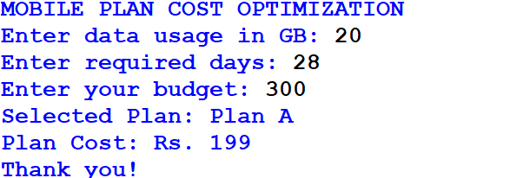

10.CONCLUSION:
The Mobile Plan Cost Optimization program successfully compares different mobile plans based on data usage, validity, and budget. It calculates the plan cost and selects the most economical suitable plan for the user. If no plan satisfies the given requirements, it displays an appropriate message. Thus, the program helps users choose a suitable mobile plan while managing their expenses efficiently.

CASE 6: Railway Fare and Reservation Calculator

1.PROBLEM STATEMENT:
Calculate fares for multiple passengers using distance slabs, travel classes, age-based concessions, reservation fees, and specified cancellation penalties.

2.OBJEVCTIVES:
- To calculate railway fares based on distance.
- To calculate fares for different travel classes.
- To provide age-based concessions for eligible passengers.
- To add reservation fees to the ticket fare.
- To calculate cancellation penalties.
- To display the final ticket amount.
3. Assumptions
- The basic fare is calculated based on the distance travelled.
- Three travel classes are available: Sleeper, AC 3 Tier, and AC 2 Tier.
- Children below 5 years travel free.
- Passengers aged 60 years and above receive a 10% concession.
- A reservation fee of ₹20 is charged per passenger.
- The cancellation penalty is ₹50 per passenger.
- All fares and concession rates are assumed for this academic case study and do not represent actual railway rules.
4. Algorithm
- Start.
- Enter the number of passengers.
- Enter the travel distance.
- Select the travel class.
- Enter the age of each passenger.
- Calculate the basic fare based on distance and travel class.
- Apply age-based concessions.
- Add the reservation fee.
- Ask whether the ticket is cancelled.
- If cancelled, subtract the cancellation penalty from the fare.
- Calculate the total amount for all passengers.
- Display the final fare.
- Stop

5.FLOW CHART:
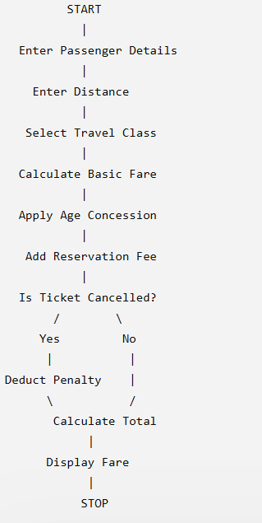

6.PSEUDO CODE:

START

INPUT number of passengers

INPUT distance

INPUT travel class

INPUT cancellation status

SET total_fare = 0

FOR each passenger:

INPUT age

IF age is below 5:

fare = 0

ELSE:

CALCULATE basic fare

IF age >= 60:

APPLY 10% concession

ADD reservation fee

IF ticket is cancelled:

SUBTRACT cancellation penalty

IF fare < 0:

SET fare = 0

ADD fare to total_fare

DISPLAY total_fare

STOP

7.PYTHON SOURCE CODE:
print("RAILWAY FARE CALCULATOR")

n = int(input("Enter number of passengers: "))
distance = float(input("Enter travel distance in km: "))

print("1. Sleeper")
print("2. AC 3 Tier")
print("3. AC 2 Tier")

choice = int(input("Select travel class: "))

if choice == 1:
rate = 1
elif choice == 2:
rate = 2
elif choice == 3:
rate = 3
else:
rate = 1
print("Invalid class. Sleeper selected.")

total = 0

for i in range(n):
age = int(input("Enter passenger age: "))

if age < 5:
fare = 0
else:
fare = distance * rate

if age >= 60:
fare = fare * 0.90

fare = fare + 20

cancel = input("Cancel ticket? (yes/no): ")

if cancel.lower() == "yes":
fare = fare - 50

if fare < 0:
fare = 0

print("Passenger Fare: Rs.", round(fare, 2))
total = total + fare

print("---------------------------")
print("Total Railway Fare: Rs.", round(total, 2))
print("Thank you!")

8.TEST CASE:
Test Case 1: When one passenger aged 25 travels 100 km in Sleeper class and does not cancel the ticket, the basic fare is ₹100. After adding the reservation fee of ₹20, the final fare is ₹120.
Test Case 2: When one passenger aged 65 travels 100 km in Sleeper class and does not cancel the ticket, the basic fare is ₹100. The passenger receives a 10% concession of ₹10. After adding the reservation fee of ₹20, the final fare is ₹110.
Test Case 3: When one passenger aged 25 travels 100 km in AC 3 Tier class and does not cancel the ticket, the basic fare is ₹200. After adding the reservation fee of ₹20, the final fare is ₹220.
Test Case 4: When one passenger aged 3 travels 100 km in Sleeper class and does not cancel the ticket, the passenger fare is ₹0 because children below 5 years travel free under the assumptions used in this case study.
Test Case 5: When one passenger aged 25 travels 100 km in Sleeper class and cancels the ticket, the fare is ₹120 before cancellation. After deducting the ₹50 cancellation penalty, the final amount is ₹70.
Test Case 6: When two passengers aged 25 and 65 travel 100 km in Sleeper class without cancelling their tickets, the first passenger pays ₹120 and the second pays ₹110. Therefore, the total railway fare is ₹230.

9.OUTPUT:
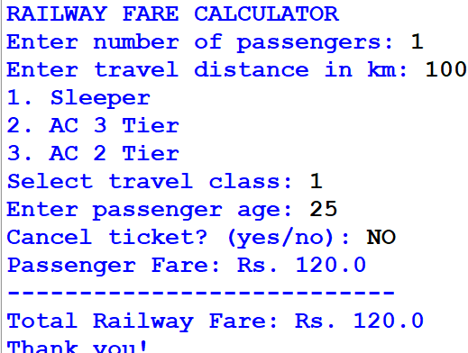

10.CONCLUSION:
The Railway Fare and Reservation Calculator successfully calculates railway ticket fares based on travel distance, travel class, passenger age, reservation fees, and cancellation penalties. It calculates individual passenger fares and displays the total amount for all passengers. This program demonstrates how Python conditional statements, loops, arithmetic operations, and user input can be used to solve a real-world railway fare calculation problem.

CASE 7: Retail Billing with Multiple Discount Rules

1.PROBLEM STATEMENT:
Process multiple products, quantities, categoryspecific taxes, threshold discounts, and maximum concession limits to generate an itemized invoice.

2.OBJECTIVES:
To calculate the price of multiple products.
To calculate the total cost based on quantities.
To apply taxes according to product categories.
To provide discounts based on the total purchase amount.
To limit the discount to a maximum amount.
To generate an itemized invoice.
3. Assumptions
The store sells Electronics, Clothing, and Grocery products.
Electronics have a 10% tax, Clothing has a 5% tax, and Grocery has a 2% tax.
If the subtotal is ₹1,000 or more, a 10% discount is applied.
The maximum discount is ₹500.
Tax is calculated after applying the discount.
All tax and discount rates are assumed for this academic case study.
4. Algorithm
Start.
Enter the number of products.
Enter the name, category, price, and quantity of each product.
Calculate the total price of each product.
Calculate the subtotal of all products.
Check whether the subtotal is ₹1,000 or more.
Apply a 10% discount if eligible.
Limit the discount to ₹500.

5.FLOWCHART:
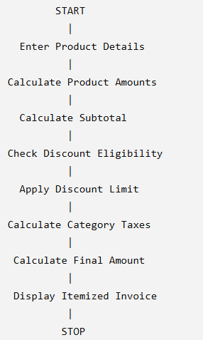

6.PSEUDO CODE:
START

INPUT number of products
SET subtotal = 0
SET total_tax = 0

FOR each product:
INPUT name, category, price, quantity
amount = price * quantity
ADD amount to subtotal

IF subtotal >= 1000:
discount = subtotal * 10 / 100
ELSE:
discount = 0

IF discount > 500:
discount = 500

FOR each product:
amount = price * quantity
discounted_amount = amount - (amount / subtotal * discount)

IF category is Electronics:
tax_rate = 10%
ELSE IF category is Clothing:
tax_rate = 5%
ELSE:
tax_rate = 2%

tax = discounted_amount * tax_rate / 100
ADD tax to total_tax

final_amount = subtotal - discount + total_tax

DISPLAY itemized invoice
DISPLAY subtotal, discount, total_tax, final_amount

STOP

7.PYTHON SOURCE CODE:
print("RETAIL BILLING SYSTEM")

n = int(input("Enter number of products: "))

names = []
categories = []
prices = []
quantities = []
amounts = []

subtotal = 0

for i in range(n):
print("\nProduct", i + 1)

name = input("Enter product name: ")
category = input("Enter category (Electronics/Clothing/Grocery): ")
price = float(input("Enter price: "))
quantity = int(input("Enter quantity: "))

amount = price * quantity

names.append(name)
categories.append(category)
prices.append(price)
quantities.append(quantity)
amounts.append(amount)

subtotal = subtotal + amount

discount = 0

if subtotal >= 1000:
if discount > 500:discount = subtotal * 0.10

discount = 500

total_tax = 0

print("\n========== ITEMIZED INVOICE ==========")
print("Product\tCategory\tAmount\tTax")

for i in range(n):
share = amounts[i] / subtotal

item_discount = discount * share
taxable_amount = amounts[i] - item_discount

category = categories[i].lower()

if category == "electronics":
tax_rate = 0.10
elif category == "clothing":
tax_rate = 0.05
else:
tax_rate = 0.02

tax = taxable_amount * tax_rate
total_tax = total_tax + tax

print(names[i], "\t", categories[i], "\t", round(amounts[i], 2), "\t", round(tax, 2))

final_amount = subtotal - discount + total_tax

print("--------------------------------------")
print("Subtotal: Rs.", round(subtotal, 2))
print("Discount: Rs.", round(discount, 2))
print("Total Tax: Rs.", round(total_tax, 2))
print("Final Amount: Rs.", round(final_amount, 2))
print("Thank you for shopping!")

8.TEST CASE:
Test Case 1: When the customer purchases one Electronics product costing ₹800 with a quantity of 1, the subtotal is ₹800. Since the subtotal is below ₹1,000, no discount is applied. The tax is ₹80, and the final bill amount is ₹880.
Test Case 2: When the customer purchases one Clothing product costing ₹1,200 with a quantity of 1, the subtotal is ₹1,200. A 10% discount of ₹120 is applied. The taxable amount is ₹1,080, and the 5% tax is ₹54. Therefore, the final bill amount is ₹1,134.
Test Case 3: When the customer purchases Grocery products worth ₹2,000, the discount is ₹200. The taxable amount is ₹1,800, and the 2% tax is ₹36. Therefore, the final bill amount is ₹1,836.
Test Case 4: When the customer purchases Electronics products worth ₹8,000, the calculated 10% discount is ₹800. Since the maximum discount is ₹500, only ₹500 is deducted. The taxable amount is ₹7,500, the tax is ₹750, and the final bill amount is ₹8,250.
Test Case 5: When the customer purchases two products, Electronics worth ₹1,000 and Clothing worth ₹500, the subtotal is ₹1,500. The discount is ₹150. The discount is shared proportionally between the products, and category-specific taxes are calculated on their discounted amounts. The total tax is ₹116.25, and the final bill amount is ₹1,466.25.

9.OUTPUT:
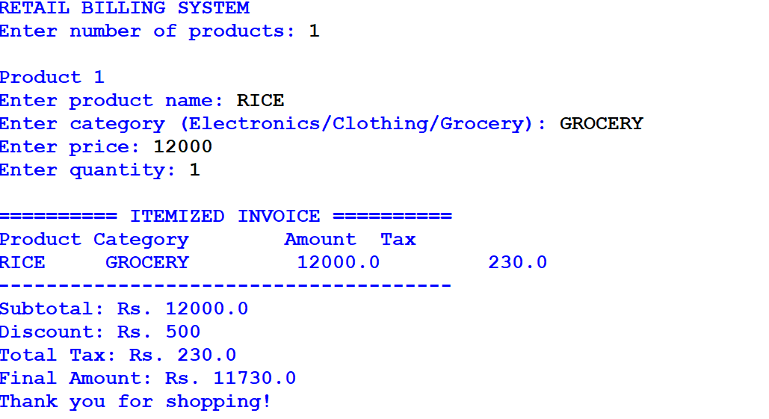

10.CONCLUSION:
The Retail Billing System successfully calculates product prices, quantities, category-specific taxes, and threshold-based discounts. It also limits the maximum discount and generates an itemized invoice showing the subtotal, discount, tax, and final amount. This program demonstrates the use of Python loops, conditional statements, lists, and arithmetic operations in a real-world billing application.

CASE 8: . Manufacturing Cost and Profitability Analysis.

1.PROBLEM STATEMENT:
Calculate material costs, labour charges, wastage, machine costs, and selling prices; identify whether production meets a specified profit target.

2.OBJECTIVES:
- To calculate the total material cost.
- To calculate labour and machine costs.
- To calculate material wastage costs.
- To determine the total manufacturing cost.
- To calculate profit and profit percentage.
- To check whether the required profit target is achieved.
3. Assumptions
- The user enters the number of products manufactured.
- Material cost, labour charges, and machine costs are entered per product.
- Wastage is calculated as a percentage of material cost.
- The user enters the selling price per product.
- The profit target is entered as a percentage.
- All calculations are based on the total production quantity.
4. Algorithm
- Start.
- Enter the production quantity.
- Enter material cost per product.
- Enter labour cost per product.
- Enter machine cost per product.
- Enter the wastage percentage.
- Enter selling price per product.
- Enter the required profit target percentage.
- Calculate the wastage cost.
- Calculate the total manufacturing cost.
- Calculate the total selling amount.
- Calculate the profit and profit percentage.
- Compare the profit percentage with the target.
- Display the results.
- Stop.

5.FLOWCHART:
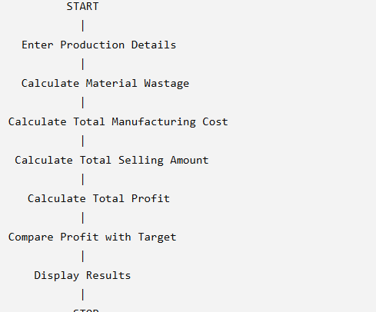

6.PSEUDO CODE:
START

INPUT quantity
INPUT material_cost
INPUT labour_cost
INPUT machine_cost
INPUT wastage_percentage
INPUT selling_price
INPUT profit_target

wastage_cost = material_cost * wastage_percentage / 100

cost_per_product = material_cost + labour_cost
+ machine_cost + wastage_cost

total_cost = cost_per_product * quantity

total_sales = selling_price * quantity

7.PYTHON SOURCE CODE:
print("MANUFACTURING COST AND PROFITABILITY ANALYSIS")

quantity = int(input("Enter number of products: "))
material = float(input("Enter material cost per product: "))
labour = float(input("Enter labour cost per product: "))
machine = float(input("Enter machine cost per product: "))
wastage = float(input("Enter wastage percentage: "))
selling_price = float(input("Enter selling price per product: "))
target = float(input("Enter profit target percentage: "))

wastage_cost = material * wastage / 100

cost_per_product = material + labour + machine + wastage_cost

total_cost = cost_per_product * quantity
total_sales = selling_price * quantity

profit = total_sales - total_cost

if total_cost > 0:
profit_percentage = profit / total_cost * 100
else:
profit_percentage = 0

print("\n----- PRODUCTION REPORT -----")
print("Number of Products:", quantity)
print("Wastage Cost per Product: Rs.", round(wastage_cost, 2))
print("Cost per Product: Rs.", round(cost_per_product, 2))
print("Total Manufacturing Cost: Rs.", round(total_cost, 2))
print("Total Selling Amount: Rs.", round(total_sales, 2))
print("Total Profit: Rs.", round(profit, 2))
print("Profit Percentage:", round(profit_percentage, 2), "%")

if profit_percentage >= target:
print("Profit Target Achieved")
else:
print("Profit Target Not Achieved")

print("Thank you!")

profit = total_sales - total_cost

profit_percentage = profit / total_cost * 100

DISPLAY total_cost
DISPLAY total_sales
DISPLAY profit
DISPLAY profit_percentage

IF profit_percentage >= profit_target:
DISPLAY "Profit target achieved"
ELSE:
DISPLAY "Profit target not achieved"

STOP

8.TEST CASES:
Test Case 1: When 10 products are manufactured with a material cost of ₹100 per product, labour cost of ₹30, machine cost of ₹20, wastage of 10%, selling price of ₹200, and a profit target of 20%, the wastage cost is ₹10 per product. The total manufacturing cost is ₹1,600, total sales are ₹2,000, and total profit is ₹400. The profit percentage is 25%, so the program displays “Profit Target Achieved.”
Test Case 2: When 5 products are manufactured with a material cost of ₹200 per product, labour cost of ₹50, machine cost of ₹30, wastage of 10%, selling price of ₹300, and a profit target of 20%, the wastage cost is ₹20 per product. The total manufacturing cost is ₹1,500, total sales are ₹1,500, and the profit is ₹0. Therefore, the program displays “Profit Target Not Achieved.”
Test Case 3: When 20 products are manufactured with a material cost of ₹150 per product, labour cost of ₹40, machine cost of ₹30, wastage of 5%, selling price of ₹300, and a profit target of 25%, the wastage cost is ₹7.50 per product. The total manufacturing cost is ₹4,550, total sales are ₹6,000, and total profit is ₹1,450. The profit percentage is approximately 31.87%, so the program displays “Profit Target Achieved.”
Test Case 4: When 10 products are manufactured with a material cost of ₹200 per product, labour cost of ₹50, machine cost of ₹30, wastage of 10%, selling price of ₹250, and a profit target of 20%, the wastage cost is ₹20 per product. The total manufacturing cost is ₹3,000, total sales are ₹2,500, and the loss is ₹500. The profit percentage is approximately −16.67%, so the program displays “Profit Target Not Achieved.”

9.OUTPUT:
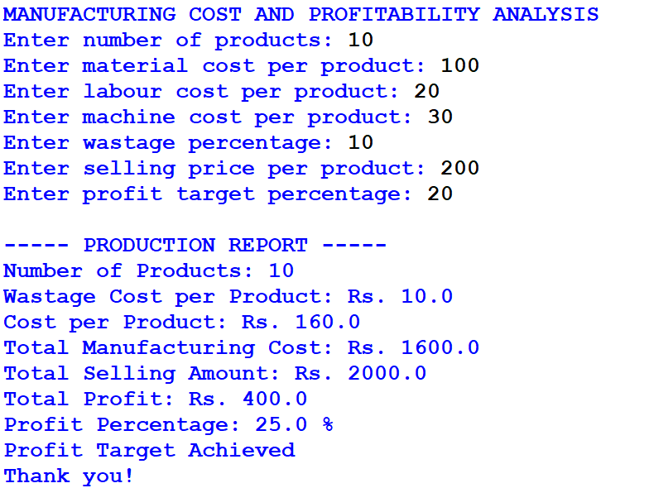

10.CONCLUSION:
The Manufacturing Cost and Profitability Analysis program calculates material costs, labour charges, machine costs, wastage costs, total manufacturing expenses, and selling revenue. It determines the profit or loss and checks whether the required profit target is achieved. This program demonstrates the use of Python variables, arithmetic operations, conditional statements, and user input to solve a real-world manufacturing problem.

CASE 9: Multi-Currency Travel Budget Analysis

1.PROBLEM STATEMENT:
Convert travel expenses using supplied exchange rates, incorporate conversion fees, compare planned spending against a budget, and identify the largest expense category.

2.OBJECTIVES:
- To convert travel expenses into Indian Rupees.
- To use supplied exchange rates for currency conversion.
- To calculate currency conversion fees.
- To compare total expenses with the travel budget.
- To identify the largest expense category.
- To display the total travel expenses and remaining budget.
3. Assumptions
- The base currency is Indian Rupees (INR).
- Travel expenses include food, accommodation, and transport.
- The user enters expenses in a foreign currency.
- Exchange rates are supplied by the user.
- A 2% currency conversion fee is applied to each expense.
- The program compares total expenses with the user's budget.
- All exchange rates and fees are assumed for this academic case study.
4. Algorithm
- Start.
- Enter the travel budget in INR.
- Enter the number of travel expenses.
- Enter the expense category and foreign currency amount.
- Enter the exchange rate for each expense.
- Convert each expense into INR.
- Calculate the 2% conversion fee.
- Add the conversion fee to each converted expense.
- Calculate total expenses.
- Identify the largest expense category.
- Compare total expenses with the budget.
- Display the expense details, total expenses, budget status, and largest category.
- Stop.

5.FLOWCHART:
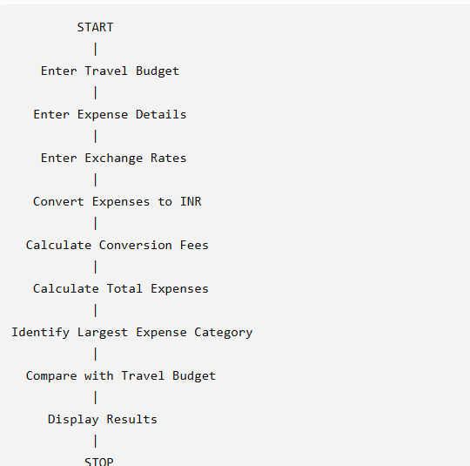

6.PSEUDO CODE:
START

INPUT budget
INPUT number of expenses

SET total = 0
SET largest_expense = 0

FOR each expense:
INPUT category
INPUT foreign_amount
INPUT exchange_rate

converted_amount = foreign_amount * exchange_rate
fee = converted_amount * 2 / 100
final_amount = converted_amount + fee

ADD final_amount to total

IF final_amount > largest_expense:
largest_expense = final_amount
largest_category = category

IF total <= budget:
DISPLAY "Within Budget"
ELSE:
DISPLAY "Budget Exceeded"

7.PYTHON SOURCE CODE:

print("MULTI-CURRENCY TRAVEL BUDGET ANALYSIS")

budget = float(input("Enter travel budget in INR: "))
n = int(input("Enter number of expenses: "))

total = 0
largest_expense = 0
largest_category = ""

for i in range(n):
print("\nExpense", i + 1)

category = input("Enter category (Food/Hotel/Transport): ")
amount = float(input("Enter foreign currency amount: "))
rate = float(input("Enter exchange rate to INR: "))

converted = amount * rate
fee = converted * 0.02
final_amount = converted + fee

print("Converted Amount: Rs.", round(converted, 2))
print("Conversion Fee: Rs.", round(fee, 2))
print("Final Expense: Rs.", round(final_amount, 2))

total = total + final_amount

if final_amount > largest_expense:
largest_expense = final_amount
largest_category = category

print("\n------ TRAVEL REPORT ------")
print("Total Expenses: Rs.", round(total, 2))
print("Travel Budget: Rs.", round(budget, 2))
print("Largest Expense Category:", largest_category)

if total <= budget:
print("Budget Status: Within Budget")
print("Remaining Budget: Rs.", round(budget - total, 2))
else:
print("Budget Status: Budget Exceeded")
print("Extra Amount Needed: Rs.", round(total - budget, 2))

print("Thank you!")
DISPLAY largest category

STOP

8.TEST CASES:
Test Case 1: When the travel budget is ₹10,000 and the user enters a Food expense of 100 units with an exchange rate of ₹80 per unit, the converted amount is ₹8,000. The conversion fee is ₹160, making the final expense ₹8,160. The program displays that the expense is within budget and identifies Food as the largest expense category.
Test Case 2: When the travel budget is ₹15,000 and the user enters a Hotel expense of 150 units with an exchange rate of ₹90 per unit, the converted amount is ₹13,500. The conversion fee is ₹270, making the final expense ₹13,770. The program displays that the expense is within budget and identifies Hotel as the largest expense category.
Test Case 3: When the travel budget is ₹5,000 and the user enters a Transport expense of 100 units with an exchange rate of ₹60 per unit, the converted amount is ₹6,000. The conversion fee is ₹120, making the final expense ₹6,120. Since the total expense exceeds the budget, the program displays “Budget Exceeded” and shows that an additional ₹1,120 is required.
Test Case 4: When the user enters three expenses—Food of 20 units at ₹80 per unit, Hotel of 50 units at ₹90 per unit, and Transport of 30 units at ₹60 per unit—the converted amounts are ₹1,600, ₹4,500, and ₹1,800 respectively. After adding the 2% conversion fee, the total expenses are ₹8,058. Hotel is identified as the largest expense category.

9.OUTPUT:
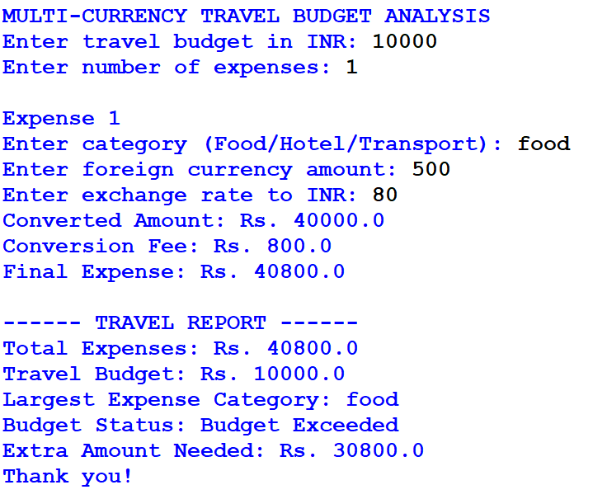

10.CONCLUSION:
The Multi-Currency Travel Budget Analysis program converts foreign currency expenses into Indian Rupees using supplied exchange rates. It calculates conversion fees, total expenses, and the largest expense category. It also compares the total spending with the planned budget and displays whether the budget is sufficient. This program demonstrates the use of Python loops, conditional statements, arithmetic operations, and user input to solve a real-world travel budgeting problem.

CASE 10: Campus Event Financial Planning.

1,PROBLRM STATEMENT:
Calculate venue, equipment, catering, transport, and certificate costs; determine participant contributions, sponsorship shortfalls, and the minimum registration count needed to break even.

2.OBJECTIVES:
- To calculate the total event expenses.
- To calculate the contribution required from each participant.
- To compare the event cost with the sponsorship amount.
- To identify the sponsorship shortfall.
- To calculate the minimum registrations needed to break even.
- To display a complete event financial report.
3. Assumptions
- Venue and equipment costs are fixed expenses.
- Catering, transport, and certificate costs are calculated per participant.
- The sponsorship amount is entered by the user.
- The registration fee per participant is fixed.
- Break-even is achieved when total income is equal to or greater than total expenses.
- All costs are assumed for this academic case study.
4. Algorithm
- Start.
- Enter venue and equipment costs.
- Enter catering, transport, and certificate costs per participant.
- Enter the expected number of participants.
- Enter the sponsorship amount.
- Enter the registration fee per participant.
- Calculate the total event cost.
- Calculate the amount remaining after sponsorship.
- Calculate the participant contribution required.
- Calculate the minimum registrations required to break even.
- Display all financial details.
- Stop

5.FLOWCHART:
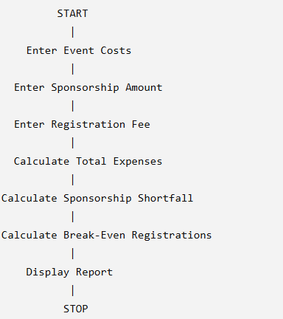

6.PSEUDO CODE:
START

INPUT venue_cost
INPUT equipment_cost
INPUT catering_per_person
INPUT transport_per_person
INPUT certificate_per_person
INPUT participants
INPUT sponsorship
INPUT registration_fee

fixed_cost = venue_cost + equipment_cost

variable_cost = participants *
(catering_per_person + transport_per_person
+ certificate_per_person)

total_cost = fixed_cost + variable_cost

shortfall = total_cost - sponsorship

IF shortfall < 0:
shortfall = 0

remaining_cost = total_cost - sponsorship

IF remaining_cost < 0:
remaining_cost = 0

IF participants > 0:
contribution = remaining_cost / participants

IF registration_fee > 0:
break_even = (fixed_cost - sponsorship) /
(registration_fee -
catering_per_person -
transport_per_person -
certificate_per_person)

DISPLAY total_cost
DISPLAY contribution
DISPLAY shortfall
DISPLAY break_even

STOP

7.PYTHON SOURCE CODE:
print("CAMPUS EVENT FINANCIAL PLANNING")

venue = float(input("Enter venue cost: "))
equipment = float(input("Enter equipment cost: "))

catering = float(input("Enter catering cost per person: "))
transport = float(input("Enter transport cost per person: "))
certificate = float(input("Enter certificate cost per person: "))

participants = int(input("Enter expected participants: "))
sponsorship = float(input("Enter sponsorship amount: "))
fee = float(input("Enter registration fee per person: "))

fixed_cost = venue + equipment

variable_per_person = catering + transport + certificate

total_cost = fixed_cost + variable_per_person * participants

shortfall = total_cost - sponsorship

if shortfall < 0:
shortfall = 0

remaining_cost = total_cost - sponsorship

if remaining_cost < 0:
remaining_cost = 0

if participants > 0:
contribution = remaining_cost / participants
else:
contribution = 0

income_per_person = fee - variable_per_person

if income_per_person > 0:
needed = (fixed_cost - sponsorship) / income_per_person

if needed < 0:
needed = 0

break_even = int(needed)

if break_even < needed:
break_even = break_even + 1
else:
break_even = -1

print("\n----- EVENT FINANCIAL REPORT -----")
print("Fixed Cost: Rs.", round(fixed_cost, 2))
print("Total Event Cost: Rs.", round(total_cost, 2))
print("Sponsorship: Rs.", round(sponsorship, 2))
print("Sponsorship Shortfall: Rs.", round(shortfall, 2))
print("Participant Contribution: Rs.", round(contribution, 2))

if break_even == -1:
print("Break-even cannot be achieved at this registration fee.")
else:
print("Minimum Registrations for Break-even:", break_even)

print("Thank you!")

8.TEST CASES:
Test Case 1: When the venue cost is ₹5,000, equipment cost is ₹2,000, catering cost is ₹100 per participant, transport cost is ₹50 per participant, certificate cost is ₹20 per participant, the expected participants are 100, sponsorship is ₹5,000, and the registration fee is ₹250, the total event cost is ₹24,000. The sponsorship shortfall is ₹19,000, and the required contribution per participant after sponsorship is ₹190. The minimum registrations required to break even are 44.
Test Case 2: When the venue cost is ₹10,000, equipment cost is ₹5,000, catering cost is ₹150 per participant, transport cost is ₹50 per participant, certificate cost is ₹30 per participant, the expected participants are 100, sponsorship is ₹10,000, and the registration fee is ₹300, the total event cost is ₹38,000. The sponsorship shortfall is ₹28,000, and the required contribution per participant after sponsorship is ₹280. The minimum registrations required to break even are 55.
Test Case 3: When the venue cost is ₹3,000, equipment cost is ₹2,000, catering cost is ₹80 per participant, transport cost is ₹20 per participant, certificate cost is ₹10 per participant, the expected participants are 50, sponsorship is ₹2,000, and the registration fee is ₹200, the total event cost is ₹10,500. The sponsorship shortfall is ₹8,500, and the required contribution per participant after sponsorship is ₹170. The minimum registrations required to break even are 29.
Test Case 4: When the registration fee is less than or equal to the variable cost per participant, the program displays “Break-even cannot be achieved at this registration fee” because the registration income cannot cover the per-participant expenses and fixed costs.

9.OUTPUT:
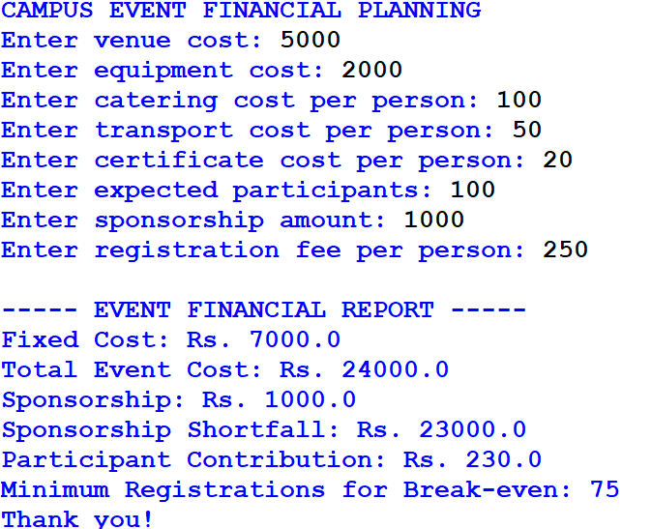

10.CONCLUSION:
The Campus Event Financial Planning program calculates fixed and variable event costs, participant contributions, sponsorship shortfalls, and the minimum registrations required to break even. It helps event organizers plan their budgets and estimate the number of participants needed to cover expenses. This program demonstrates the use of Python variables, arithmetic operations, conditional statements, and user input in financial planning.

